Dŵr Cymru Welsh Water Customer Challenge Group Terms of Reference
Helping to ensure that current and future customers are at the heart of the way Dŵr Cymru Welsh Water operates.
The role of the Customer Challenge Group (CCG) is to provide independent challenge, scrutiny and advice on the:
- quality of the company’s customer engagement and involvement
- extent to which the results of this engagement are reflected in the company’s decision making, business planning and operations.
- the return of value to customers from the “Glas Advantage”

The Customer Challenge group will provide:
- independent reports and recommendations, through the Chair, to the Glas Cymru Board
- an annual independent commentary on the Performance Report of the company including delivery of outcomes and service improvements set out in current regulatory business plans
- independent reports and assurance to Ofwat as required for the next price review - PR19
- public reports on its operations via the company CCG web page, including an annual report of the work of the CCG.

The Customer Challenge Group aims to ensure that the company:
- understands and responds to domestic, business and other non-household customer needs and requirements
- uses a wide evidence base to develop an understanding of customer needs, requirements and willingness to pay
- explains its obligations, key business priorities and investment plans well to its customers and stakeholders
- fulfils the customer expectations in the delivery of the business plan and communicates its performance to its customers and interested parties
- identifies the distinct needs and requirements of different types of customers, specifically recognising the priority needs of vulnerable customers
- has long term strategic objectives, future business plan and investment proposals takes into account the wellbeing of future generations.
- supports where possible collaborative opportunities and joint capital investment in order to ensure an integrated approach to community resilience
- involves customers in decisions related to the return of value to the customers from the “Glas Advantage” fund
- enables a two way dialogue focused on educating and informing customers, as well as seeking feedback
- embeds customer led development across the business with clear leadership at Board level
- business plan delivers a balance of economic, social and environmental benefits for current and future generations

The Customer Challenge Group will:
- have an independent chair appointed through Glas Cymru’s Independent Appointments Panel
- consist of independent members with relevant expertise
- hold meetings 4 times a year to align with the business reporting timetable in order to provide independent commentary on company performance.
- Set a work programme, meeting and reporting schedule to meet the Ofwat requirements for PR19
- Involve the statutory regulators and draw on other specific expert input and challenge as appropriate to contribute to relevant agenda items.
- draw on the expertise Consumer Council for Water, share practice and experience with other Customer Challenge Groups, and other customer reference groups from across the Utilities
- ensure a close operating link with the company’s Independent Environmental Advisory Panel
- hold meetings at different company locations and participate in visits to build understanding so as to improve the quality of challenge
- respect the confidentiality of information provided when necessary
- seek the expert input of its members in specialist discussions as well of external experts as and when required
- review its performance annually linked to the production of an annual report detailing its work

The Company will support the operations of the Customer Challenge Group through providing
- all the necessary information to ensure the CCG understands its obligations, priorities, business plans and that customer requirements are being met through its operations
- recognition of the role of the CCG in its business processes, internal communications and specifically with contractors undertaking work on its behalf with customers
- senior level representation at all CCG meetings
- appropriate opportunity for the Chair to attend and present reports from the CCG to the Board
- responses to recommendations and reports from the CCG
- a secretariat who will work to the Chair in arranging meetings, circulating agendas, briefing materials and preparing minutes
- a Customer Challenge Group page on its web site, which will hold details of the group, reports of meetings and other updates as agreed with the Chair www.dwrcymru.com/en/Customer-Service/Your-Company-Your-Say/CCG.aspx
- a budget to cover associated operating expenses for the Group

The membership of the CCG will:
- be appointed by the Chair in consultation with the company and CCG members
- be independent of the company and appointed on an individual basis,
- provide it with a wide range of knowledge and experience of the issues affecting customers within the Company’s region
- possess knowledge in areas including customer advocacy, community engagement, customer research, behavioural change, business planning, environmental concerns
- include representation from the Consumer Council for Water and a debt advisory body
- will normally have 12 members in addition to the Chair, but will also have powers to co- opt additional members to ensure its effectiveness. The appointments will be for the period of the PR19 review to 2020.

The Chair of the Customer Challenge Group will be responsible for:
- ensuring the Group meets its responsibilities to Welsh Water customers and to Ofwat
- developing working relationship with the company CEO, Senior Executives, Chair and Board
- recruitment and involvement of members of the CCG
- the efficient operations of the group and participation of group members
- engaging with external networks to inform the work of the group
- representing the group at meetings with Ofwat, CCG Chairs, CCWater, The Wales Water Forum, Welsh Government PR19 Review Group, etc
- reporting to the Welsh Water CEO issues raised by the Group following each meeting
- providing a monthly update briefing to Group members
- preparing reports on behalf of the Group as required by the Ofwat PR19 process

Quorum
The quorum necessary for the transaction of business shall be five. In the absence of the Chair, the Chair may nominate a deputy to chair a meeting. If the Chair is unable to do so, the members may elect a Chair for the meeting.

Peter Davies
Chair of Dŵr Cymru Welsh Water Customer Challenge Group
July 2016

CCG Members
 | Peter Davies  Chair of the CCG  Peter’s career background is in the area of corporate responsibility working for the Confederation of British Industry, Department of Trade and Industry (DTI) and Business in the Community where he was managing director from 1995 to 2005.  He was awarded the OBE in 1995 for work in establishing links between business and education under the DTI’s Enterprise Initiative. He returned home to Wales in 2005 and was appointed Commissioner for Wales and Vice Chair of the UK Sustainable Development Commission.  Following the closure of the UK Commission he became Wales' first Sustainable Futures Commissioner and chair of the Climate Change Commission for Wales from 2011 to 2016. He was awarded a CBE in 2016 for his work in these roles.  His current project portfolio focuses on working in support of communities, citizens and consumers. This includes chairing the Wales Council for Voluntary Action, the Size of Wales charity, being a Director of Pembrokeshire Community Energy and a member of the BT Wales Advisory Board.  He joined us as chair of the Customer Challenge Group in February 2016 for a five year term.
 | Professor Steve Ormerod  Cardiff University  Steve is currently Professor of Ecology at Cardiff University where he has gained 35 years’ research experience and produced around 270 scientific publications. His work focuses on catchment-scale problems affecting freshwater biodiversity, ecosystem quality and ecosystem function. He is known best for flagship studies on the effects of acid rain and climate change on aquatic organisms, river birds and river ecosystem services.  As well as being a member of the CCG Steve is also Chairman of the Council of RSPB (Europe’s largest wildlife charity), Chairman of the Centre of Ecology and Hydrology Scientific Development Group and the Chairman of our Independent Environment Advisory Panel (IEAP).
 | Dimitrios Xenias  Research Associate, Cardiff University and Tyndall Centre for climate change research.  Dimitrios is an environmental psychologist, looking at energy and water consumption as well as EU environmental policy making (focusing on energy and transport). His research focuses on the social psychology of sustainable behaviours and associated technologies (for example, renewable energy, electric vehicles), as well as natural resource conservation and climate risks communication.  As well as being a Research Affiliate of the Sustainable Places Research Institute at Cardiff University and the Tyndall Centre for Climate Change Research, he is also a reviewer for the European Commission and a member of Cardiff University's Water Research Institute.  Dimitrios has been a member of the CCG since 2016 and is also a member of our Independent Environment Advisory Panel (IEAP).
 | Lia Moutselou  Policy Manager, Consumer Council for Water  Lia is the Policy Manager for the Consumer Council for Water in Wales and has been involved in three water industry price reviews to date. She contributes research and industry performance updates to the CCG. Lia liaises with the Welsh Government on behalf of CCWater and had in the past led the resilience portfolio for the policy team. Lia has extensive experience in stakeholder engagement, policy and legislation analysis and advocacy through her work at the Wales Coastal and Maritime Partnership, Cardiff University and through her previous freelance work. Lia has legal and social research background, has worked on various research projects at Cardiff University and had been responsible for the delivery of an interdisciplinary Environmental Law module at various departments at Cardiff University.  She is passionate about community work and continues to be involved in various local projects relating to environmental behaviour change and the integration of refugee, asylum seekers and immigrants.
 | Duncan McCombie  Duncan has worked across the utility sector including Energy Saving Trust, Thames Water and Consumer Council for Water, working to Board level, delivering a broad range of government and commercial projects, in the UK and abroad.  His Civil Engineer qualifications have provided him with a diverse career in the water sector, working across engineering, customer services, regulation and more focused roles on sewer flooding and droughts. He is very experienced in making a transitional impact in the utility sector having recently led Energy Saving Trust in Wales and Ireland to a sustainable commercial long term future following a significant reduction in direct government funding. At this time has was also invited to sit as a Climate Change Commission member for Wales, Chair of the Existing Homes Network and still sits on the Western Power Distribution Customer Panel and Wales and West Utilities Critical Friend Panel.  Duncan has been a member of the CCG since 2016.
 | Rachel Lewis-Davies  Environment / Rural Affairs Advisor for NFU Cymru  Rachel Lewis-Davies is Environment / Rural Affairs Advisor for NFU Cymru protecting and furthering members’ interests on environmental and rural policies in Wales. She is the Unions’ main contact for engagement with Natural Resources Wales and with other statutory and non-statutory bodies involved with environmental and rural policy formulation and implementation.  A partner in a farm business, Rachel studied Environmental Management and European Rural Development at University and has significant experience of agriculture and rural development having worked in the sector for over 20 years.  Rachel became a member of the CCG in 2016 and represents farmers and land owners and is particularly interested in how we can work together to improve water quality.
 | Delyth Jewell  Policy Manager Citizens Advice  Delyth has been a Policy Manager for Citizens Advice since March 2015, and concentrates on public services and consumer issues. She is interested in supporting and representing vulnerable customers through the CCG such as those who struggle to pay their water bills.  Delyth joined Citizens Advice after spending five and a half years in the House of Commons, where she was Head of Research for the Plaid Cymru parliamentarians, as well as a speechwriter. She specialised in social justice issues, and played a key role in cross-party campaigns which led to new laws being introduced on stalking (2012) and coercive control (2015). In 2014, Delyth was awarded the prize of ‘Overall Researcher of the Year 2014’ in the DODS Parliamentary Researcher of the Year Awards.  Delyth holds Masters and Bachelor’s degrees from the University of Oxford and became a member of the CCG in 2016.
 | Lee Gonzales  Consumer Council for Water  Lee has been a Local Consumer Advocate for CCWater since April 2015. He represents CCWater on the CCG and holds the affordability portfolio within the Wales Committee. Lee is a research scientist with particular expertise in biophysics and analytical chemistry and a former research fellow at Cardiff University. He is an Adjunct Associate lecturer (Charles Sturt University), a current committee member for the Royal Society of Chemistry analytical methods sub-groups for statistics and heritage science and has been a member of the National Assembly for Wales’ cross-party group for Science and Technology. He has a passion for working with disadvantaged people and has previously been a trustee of Vale for Africa, a charity working with rural communities in Uganda and also involved with the Jubilee Sailing Trust, helping disabled people to sail tall ships.
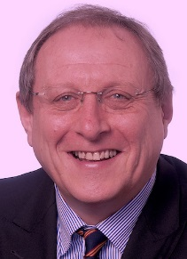 | Craig Anderson  Director ACL Planning & Development  Craig is an architect/town planner with over 30 years’ experience in area regeneration and job creation. This has involved large-scale redevelopment of both housing, commercial and industrial areas across his native Scotland and then Wales and England where he operated at Director-level for local government and prior to that with the Scottish Development Agency.  Craig is former CEO of Warm Wales Cymru Gynnes, the first UK Community Interest Company specialising in relief of Fuel Poverty which he led until 2017. Since its inception WW~CG has delivered 60,000 house upgrades and has pioneered mass retrofit through both the Welsh Government Arbed Programme and more recently the Solcer Retrofit programme of ‘buildings-as-power stations’ led by the Cardiff University Welsh School of Architecture. This has involved whole house insulation combined with the latest mechanical ventilation and solar renewables low-carbon technologies linked to battery storage.  Since 2015, Craig has pioneered the FRESH Vulnerability Mapping system as an aid for local authorities working with utility providers and third sector local agencies to target resources towards the most vulnerable households. This initiative has received national awards and recognition and is being progressively rolled out throughout Welsh Local Government. It is also being used in the UK Government ECO-Flex Pathfinder in Cornwall. A key focus for Craig now is helping homeless partnerships in attracting investment for ‘housing-first' to address the growing UK-wide rough sleeping and homelessness crisis.
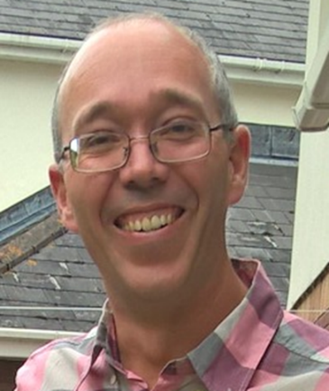 | Geraint Weber  Water Strategy Specialist Advisor in Natural Resources Wales  This role includes programme management of NRW’s approach to PR19. He has fifteen years of experience working for the environmental regulator in Wales, much of which has focussed on Water Framework Directive planning and delivery.
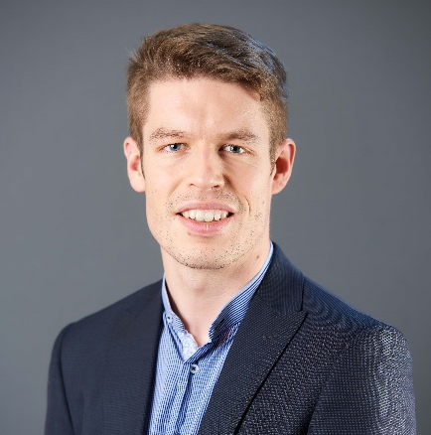 | Matt Williams  Policy Advisor for the Federation of Small Businesses  Matt Williams is a Policy Advisor for the Federation of Small Businesses in Wales, the FSB represents around 10,000 small and medium sized enterprises in Wales and works to protect their interests and create a healthy environment for business to thrive. At the FSB his portfolio covers taxation, non-domestic rates, the environment, and transport amongst others, with responsibility for the commission, design and authoring of research reports and policy proposals in these areas. Previously, Matt has worked in the renewable energy industry, at a political consultancy, and on a number of rural development programme projects in rural Wales.
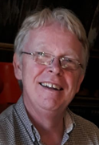 | Bill Darbyshire  Environment Agency’s lead on the CCG  He has 25 years’ experience working as an engineering contractor; an environmental consultant and for as an environmental regulator. His current role is in supporting the development of the strategic environmental plans which ensure that the rivers, lakes and ground waters in England achieve their environmental potential to help deliver more for local communities. A passionate advocate for the environment, he believes that facing the big challenges of climate change, flood risk and river quality should be done in a way that brings benefits for people and businesses.
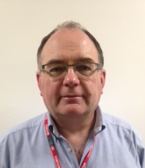 | Richard Garner Williams  Salmon and Trout Conservation’s National Officer for Wales  Having previously served as a trustee of the charity his duties now involve advocating on behalf of the wild fish of Wales and the many other species that inhabit our streams and rivers. His life-long passion for angling has provided him with a profound understanding of the need to restore and protect the ecological integrity of freshwater environments. Richard graduated from Aberystwyth University with a BSc in Zoology and subsequently gained an MSc in Farmland Conservation and Animal Welfare at Harper Adams University. Richard has served on the CCG since 2012 as a representative of Wales Environment Link (WEL), a network of environmental, countryside and heritage non-governmental organisations with an all-Wales remit. WEL aims to positively influence the development of policy, legislation and practice in Wales by providing a voice for the environmental NGO sector.
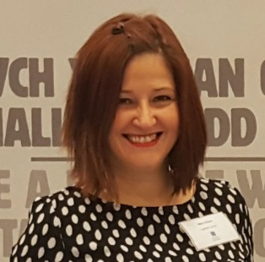 | Mari Arthur  Director, Cynnal Cymru – Sustain Wales and Governor for Stebonheath School  Mari is an experienced marketing and business strategist having worked in a number of private and public sectors. Mari has business development, PR, sales, marketing, events, design, and project and account management experience and has worked in a number of industries including education and new technology.  Previous to joining the Cynnal Cymru team Mari managed a marketing consultancy and has worked regularly with organisations in the Far East, Middle East and Russia on business development and links with Wales. Since 2010 Mari has established two limited companies in Cardiff employing over 30 staff. Mari has not only launched and grown her own companies but has advised and supported other organisations and start-ups on business resilience and sustainability.

