Natural Resources Wales Annex to Dwr Cymru Welsh Water Customer Challenge Group Report

Introduction
The Wellbeing of Future Generations (Wales) Act 2015 establishes a framework for public bodies in Wales to improve social, economic, cultural and environmental well-being in accordance with the principles of sustainable development. The Environment (Wales) Act 2016 puts in place a process to help plan and manage our natural resources in a more sustainable and joined up way. We want to see PR19 business plans reflect the nature of the distinct legislative framework in Wales.
The State of Natural Resources Report (SoNaRR) underlined that Wales’ natural resources provides us with a wide range of benefits and a wealth of opportunities. These include supporting the prosperity and health of our nation. The report also underlined the need to improve the way we manage our natural resources so that a more sustainable flow of benefits is achieved. Welsh Government’s Natural Resources Policy informed by SoNaRR, focuses on improving the way we manage our natural resources to deliver Wales’ Well-being Goals. It identifies three priorities:
- Delivering nature-based solutions;
- Increasing renewable energy and resource efficiency; and,
- Taking a place-based approach.
Water is a very valuable natural resource. Present and future generations have a strong interest in ensuring that water is managed sustainably to enable healthy lives and high-value economic activities. Adequate water and wastewater infrastructure is needed to support sustainable development, thriving communities and healthy and resilient ecosystems.
As the principal environmental regulator in Wales, NRW’s purpose is to pursue the sustainable management of natural resources in relation to Wales and apply the principles of sustainable management of natural resources in the exercise of our functions. Our work includes championing sustainable management of natural resources through our role on the Dwr Cyrmu Welsh Water (DCWW) and Hafren Dyfrdwy Customer Challenge Groups (CCGs); along with working with both companies to develop a National Environment Programme (NEP) to meet their statutory obligations and national policy priorities across their operations, including water resources, water quality and their section 6 biodiversity and ecosystem resilience duty. We are also a statutory consultee and advisor to the Welsh Government on water company water resources management plans (WRMPs).
Following submission of Water Company business plans, we will continue to support Ofwat in its PR19 scrutiny process.

Ambition
DCWW’s customer research has demonstrated the importance that customers place on the environment and investment for the long term. There is also customer support for catchment management and sustainable drainage, such as the nature-based solutions that have been identified as a priority in Wales’ Natural Resources Policy. We feel this provides a strong basis for an ambitious PR19 plan to address environmental challenges framed in Welsh Water 2050.
We are mindful of the need to avoid storing up problems for future generations to pay for and the need not to delay where a problem could cost more to address in the long term. Equally, we welcome the company’s proposals to innovate and seek sustainable, long term and cost-effective solutions by working in catchments and in partnership to deliver environmental requirements and meet its statutory obligations. We are conscious of the need to strike a balance between delaying investment and action to find the right solution against the consequences for future price reviews.
Therefore, any phasing of environmental improvements or the setting of environmental targets should be with a full understanding of consequences for AMP8 and beyond, and in the knowledge that new obligations are likely to be identified alongside any phased investment.

Statutory obligations: National Environment Programme
We have worked with DCWW to develop a National Environment Programme (NEP) to meet their statutory obligations and national policy priorities. In July 2018 NRW issued NEP4.1 setting out the obligations and expectations that water companies in Wales must consider when developing business plans for the price review.
DCWW raised concerns over the affordability of NEP4.1 if they were to employ traditional solutions, and wrote to Welsh Government (WG) to propose a phased approach to delivery over the next 10 years to include greater working with partners. WG have indicated their acceptance of the proposal.
We welcome DCWW’s commitment to look at innovative and cost-effective options (including catchment and end-of-pipe) to deliver the NEP 4.1 requirements. In principle, where delaying delivery will lead to more cost-effective solutions and deliver more for the environment and people, we support DCWW’s proposal. This does not preclude regulatory enforcement action being taken or the need to bring investment forward, where there is evidence over the PR19 plan period of non-compliance and significant environmental and/ or public concern.
There are some aspects of the company’s proposed programme that NRW will continue to discuss further with the company, including for example: firm delivery proposals which will allow progress to be tracked through our close working liaison arrangements; reassurance over the delivery of the proposed deferred WFD programme by 2027; and to further understand the need for the super works on the Gwilli-Gwendraeth.
NRW is committed to developing a collaborative approach to achieving SMNR and look forward to continuing to work with DCWW and others on several key topics, including flexible permitting, nutrient off setting, sustainable drainage, and drainage & waste water management plans. We are pleased that DCWW will play a leadership role in this.

Measures of Success & Targets
As discussed at the PR19 Forum, the Annual Performance meeting and the CCG, we have expressed concern as to whether some of the Measures of Success linked to rewards and penalties are stretching enough.
We recognise the time and effort DCWW have invested in reducing pollution incidents in recent years, however we expect them to set stretching targets for PR19. Their current performance of wastewater incidents is 102, but the stated ambition to reduce to 90 incidents over 5 years is disappointing and we encourage the company to seek a more stretching target, since we are concerned this will see DCWW fall behind the rest of the industry. As presented to the CCG, the company’s own analysis suggests that it would be cost-beneficial to set a target of 75 incidents. We believe pollution reduction needs to be firmly embedded in the values and operational practice of DCWW as a minimum, and that rewards should only be achieved where DCWW goes further or faster.
We are pleased with the company’s commitment to aim to meet Ofwat’s challenge of reducing leakage by 15% by 2025. We expect all companies to deliver the target by taking a company-wide approach across all zones, and to explore the use of innovative approaches to achieve leakage reductions.
We are reassured to see that the target for compliance measures is 100% and that these targets are linked to penalties only. In relation to bioresources disposal (sewage sludge recovery) we would like to see the company develop and deliver a clear sludge strategy that outlines how it will be resilient and ensure there is sufficient treatment, handling, recovery and if needed disposal capacity to prevent environmental impacts.
We have yet to verify the target proposed for kilometres of river improved. We understand this measure is linked to the company’s proposals for delivering NEP4.1 requirements and would have concerns if the company received a reward without going beyond its statutory requirements.

Long term planning: Welsh Water 2050
We very much welcome the development of Dwr Cymru Welsh Water’s 2050 vision. This is a positive step in terms of identifying and framing the strategic challenges, responses and options that the company faces. However, we are disappointed that the long-term context and full investment requirements were not presented clearly as part of customer research and business planning in PR19 and would want to see more emphasis on this in PR24.
We expect the company to take the lead in developing a comprehensive long-term plan for meeting the requirements of their waste water network, as set out by the C21st Drainage Programme.

Sustainable Management of Natural Resources (SMNR)
We are encouraged by recent discussions with DCWW to embed the principles of SMNR in their approach to delivering PR19 and future outcomes.
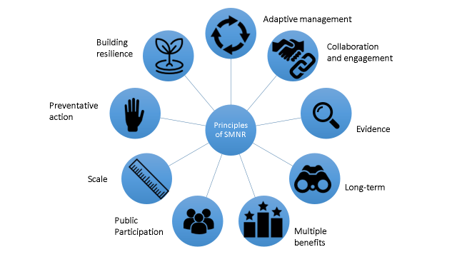
We welcome their proposals for catchment solutions to some of its drinking water and waste water problems. The proposals for Brecon Beacons, Afan, Clwyd, Alyn and Teifi catchments are in line with Wales’ legislative framework and have the potential to deliver cost-effective outcomes and multiple benefits at scale, as well as exploring new ways of working to inform future delivery. NRW has issued a letter of support for inclusion of the Brecon Beacons Mega catchment and the other drinking water catchments within the business plan.
Customer research has revealed significant support for catchment work and innovation and we support DCWW`s early thinking around a more ambitious programme of integrated catchment solutions, in particular where there is a need to also secure commitments from other land and water users, who in many cases are also customers. We are pleased that the company are committed to developing leadership in delivering the ways of working and outcomes of Wales’ new legislative framework, and in so doing provide its customers with long term sustainable solutions which deliver wider benefits.

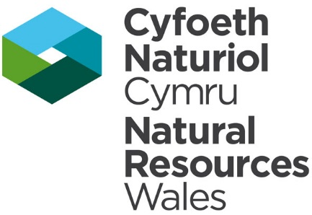
Natural Resources Wales
Cambria House,
29 Newport Road
Cardiff
CF24 0TP

28th August 2018

Dear Phillippa

We have worked with DCWW to develop a National Environment Programme (NEP) to meet its statutory obligations and national policy priorities. NEP4.1 sets out the obligations and expectations that water companies in Wales must take into account when developing business plans for the price review.

The Environment (Wales) Act 2016 puts in place a process to help plan and manage our natural resources in a more sustainable and joined up way. We want to see PR19 business plans reflect the nature of the distinct legislative framework in Wales.
Welsh Government’s Natural Resources Policy informed by the State of Natural Resources Report (SoNaRR), focuses on improving the way we manage our natural resources to deliver Wales’ Well-being Goals. It identifies three priorities:
- Delivering nature-based solutions;
- Increasing renewable energy and resource efficiency; and,
- Taking a place-based approach.

We are therefore supportive of the company’s catchment proposals to protect drinking water sources. We await the environmental evidence to confirm their inclusion as amber/green in the National Environment Programme as schemes required to meet WFD Article 7 Drinking Water requirements, which is a necessary part of the periodic review process. We welcome the approach which seeks to take preventative, precautionary and collaborative action to manage catchment to protect raw water quality to ensure that deterioration does not occur and that the risk from catchments to drinking water remains low.

We consider that the proposals for Brecon Beacons and other drinking water catchments are in line with Wales’ legislative framework and have the potential to deliver cost-effective outcomes and multiple benefits at scale, as well as exploring new ways of working to inform future delivery and in so doing provide its customers with long term sustainable solutions which deliver wider benefits.

Tŷ Cambria • 29 Heol Casnewydd • Caerdydd • CF24 0TP
Cambria House • 29 Newport Road • Cardiff • CF24 0TP
Croesewir gohebiaeth yn y Gymraeg a’r Saesneg
Correspondence welcomed in Welsh and English

We look forward to continuing to work with the Company through the sharing of information and the identification of joint opportunities for preventing deterioration, environmental improvement and using monitoring evidence alongside other information to target measures effectively and evaluate the success of their innovative proposals.

I am copying this letter to:
- Jon Ashley and Kevin Ridout at Ofwat;
- Eifiona Willams at Welsh Government
- Peter Davies (Dwr Cymru Welsh Water’s Customer Challenge Group)
- Milo Purcell at the Drinking Water inspectorate
- Tom Taylor (CCW Chair, Wales)

Please contact Natalie Hall (natalie.hall@cyfoethnaturiolcyrmu.gov.uk) with any queries relating to this letter.

Yours sincerely

Ceri Davies
www.naturalresourceswales.gov.uk
www.cyfoethnaturiolcymru.gov.uk

